Framework Architecture

History
Date | Version | Comment
March 13th, 2007 | 0.2 | Updated following project restructuring
July 5th, 2006 | 0.1 | Initial Version

Contents
1 History 2
2 Contents 3
3 Overview 4
4 Definitions and acronyms 4
5 Software architecture 5
5.1 Overall architecture 5
5.2 Components implementation 5
5.2.1 ODF Zip Utils 5
5.2.2 ODF Converter Library 5
5.2.3 ODF Add-in 5
5.2.4 ODF Converter Test 5
5.2.5 ODF Setup 5
6 References 6

Overview
This document describes the common ODF Converter architecture for Word, PowerPoint and Excel.

Definitions and acronyms
Expression | Definition
OOX | Office Open XML file ( “.docx” suffix for Word 2007 documents)
ODF | Open Document File
Add-in | Component that can be integrated into another application

Software architecture

Overall architecture
The ODF Converter has a modular architecture which allows conversion for different applications (i.e. Word, Excel, and PowerPoint) as well as providing a command line tool and a seamless integration with windows explorer.
All the components were implemented using the .NET Framework and Visual Studio 2005.
The architecture is based on a stack of components, each component using the services from the component beneath. Figure 1 depicts the architecture with its various components.
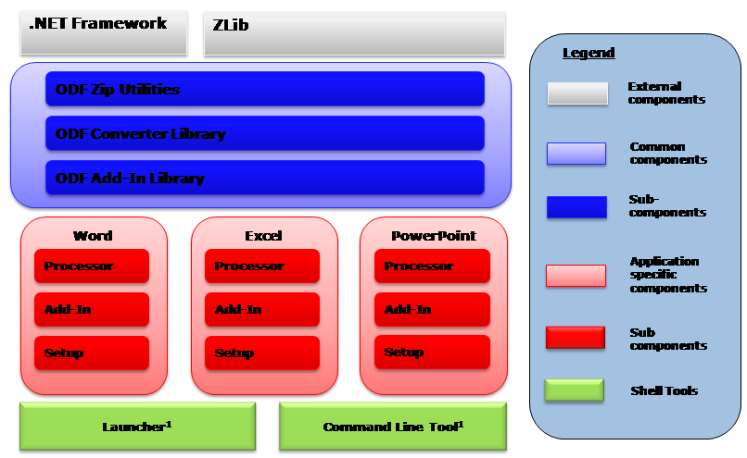
Figure 1: SW Component Architecture

Component Description
The following is a description of each component.

External Components
The external components are third party components which were re-used for this project:
- zlib is a free software/open-source, cross-platform data compression library. It is an abstraction of the DEFLATE compression algorithm used in the gzip file compression program. The first public version was originally intended for use with libpng image library. zlib is distributed under the zlib license. We use this library to access ODF and OOX files’s content.
- The Microsoft .NET Framework provides a large body of pre-coded solutions to common program requirements, and manages the execution of programs written specifically for the framework. In our case we use it essentially for the XSL processor and to integrate the converter as MS Office Add-In.

Common Components
The common components are a collection of components shared across the application specific implementations:
- ODF Zip Utils: provides a .NET API for reading and saving ZIP files. This is based on the zLib external component.
- ODF Converter Library: implements the whole transformation processing chain in both directions. It also implements the resolvers, the common post-processors, and instantiates the XSL processor engine.
- ODF Add-In Library: This is the common code to the Add-In and implements the converter dialog boxes, manages message events & initiates the conversion.

Application Specific Components
These components are application specific and provide seam-less integration with the rest of the architecture.
- Processor: This is a container for the xsl transform documents as well as the post-processors.
- Add-In: This is the component responsible for displaying the ODF Menu in the application.
- Setup: Installation utilities.

Shell Tools
These are peripherals tools which are not directly integrated in the final applications. Note that those utilities only use the processor sub-components from the application layer.
- Launcher: A utility allowing the user to convert (and open) a ODF document directly from windows explorer.
- Command Line Tool: A command line tool utility.

Components implementation

ODF Zip Utils
In addition to providing an API for handling ZIP files, the ODF Zip Utils library provides a way to package XML fragments and external binary files into a ZIP archive. It is done through the ZipArchiveWriter class, which is a custom implementation of System.Xml.XmlWriter.
The input XML stream must conform to the following structure:
<zip:archive zip:target="somePath">
<zip:entry zip:target="relativePath">
<!-- xml fragment to be packaged -->
</zip:entry>
<!-- other entries -->
...
</zip:archive>

The ODF Zip Utils library contains the following classes:
- ZipLib: Interop layer for zlib library
- ZipReader: Abstract class for ZIP file read operations
- ZipWriter: Abstract class for ZIP file write operations
- ZlibZipReader: Actual implementation of ZIP file read operations: derived from ZipReader and based on ZipLib
- ZlibZipWriter: Actual implementation of ZIP file write operations: derived from ZipWriter and based on ZipLib
- ZipArchiveWriter: package XML fragments and external binary files into a ZIP archive
- ZipEntryNotFoundException: Thrown when an entry is missing in the ZIP file
- ZipException: Thrown when other errors are encounted by the Zlib library.

ODF Converter Library
The main part of the converter library consists of XSL Transformations. Those are used to convert an XML serialization of ODF into an XML serialization of OOX and vice-versa. Since the xsl transform sheets are embedded in a binary assembly during execution, a “resource Resolver” was created. This one allows to fetch xsl files at load time and is invoked by the xsl:import element during the transformation.
As both ODF and OOX are embedded XML files and resources into ZIP archives, a “ZIP resolver” that extracts the data from the archive has been implemented. Also, the final result needs to be saved in a ZIP archive (whether it be OOX or ODF). This is done thanks to a special post processor called the ZipArchiveWriter, which serializes an XML file with several logical blocks, each of which corresponding to a single XML file after post-processing (See section above). In this scenario, the XSL transformation replaces all links, footnotes, images, etc. with references as it will be in the final XML files.
. Figure 1 shows the various resolvers and the logical chain of events during a conversion.

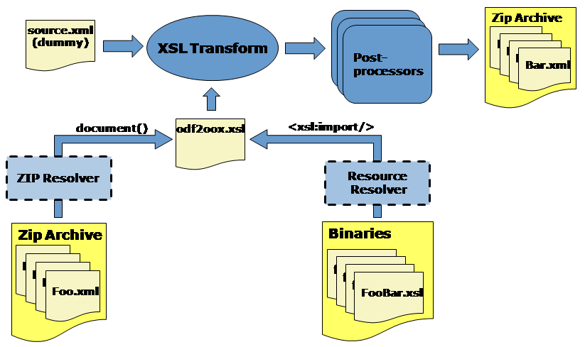
Figure 2: Logical Processing Chain
The ODF Converter Library contains the following classes :
- Converter: Controler of the conversion process
- ResourceResolver: Used to locate and access embedded resources, typically xsl stylesheets embedded in the library
- ZipResolver: Used to locate and access zip resources, typically document parts
- NotAndOdfDocumentException: Exception raised when the file to convert is not an ODF document

ODF Addin Component
This component provides a user interface to the ODF Converter:
- it add an “ODF” menu with a “Open ODF…” menu item,
- it then provides a file selection dialog box allowing the user to select one or more files to be converted and opened
- it displays for each conversion a progress dialog with the option for the user to cancel the conversion.
This component is build of two classes:
- Connect: Provides the integration into word and controls the conversion process
- ConvertForm: Provides the progress user interface with the cancel button

ODF Converter Test
This component is the command line translator. It currently offers the possibility to either convert an ODF file or to validate the XML schema of a resulting file.
This component is build of two classes:
- OdfConverterTest: Entry point of the translator; parses the parameters and launch the conversion process
- OoxValidator: Validates the schema of a result file

ODF Setup
This component is the installation program for the ODF Add-in for Word 2007. It copies the required components as well as the readme file in the target directory.

References
[RefId] | <Title>
Author
Location
Doc ID

[RefId] | <Title>
Author
Location
Doc ID

…

